Inventory Management System (IMS)
Software Development Plan & Requirements Specification
Author: Juan Rojas
Course: CEN 3024C – Software Development I
System Name: Inventory Management System (IMS) – Client/Server Version

Table of Contents
- Introduction
1.1 Purpose
1.2 Scope
- System Overview
2.1 Object Definitions
2.1.1 Product
2.1.2 User
2.1.3 Supplier
- Functional Requirements
3.1 CRUD Operations
3.2 Custom Actions
3.3 User Roles and Access Control
- Non-Functional Requirements
4.1 Security
4.2 Reliability
4.3 Performance
4.4 Scalability
4.5 Maintainability
- Architectural Design – 3-Tier Model
5.1 Tiers
5.2 SQL Schema (Core Tables)
- User Interface Overview
- User Stories & Use Cases
7.1 Key User Stories
7.2 Use Case Summaries
- UML Diagrams (Guidance)
- Process & Management
9.1 Development Process
9.2 Tools & Technologies
9.3 Testing Strategy
9.4 Risk & Mitigation
- Incident Management
10.1 Incident Report Template
10.2 Example Incident Report

1. Introduction

1.1 Purpose
This document defines both the Software Development Plan (SDP) and the Software Requirements Specification (SRS) for my small Inventory Management System (IMS).
It is intended for:
- Stakeholders / Clients – to understand what the system will do and what quality levels to expect.
- Developers & Testers – to implement and verify the system behavior.
- Future Maintainers – to safely extend the system without breaking existing features.
The IMS manages Products, Users, and Suppliers using a 3-tier, client–server architecture with a JavaFX front end, a Java server over SSL, and a MySQL database.

1.2 Scope
Current scope (this release):
- Multi-user Inventory Management over the network (client–server).
- CRUD operations for:
  - Products (core inventory)
  - Users (login accounts & roles)
  - Suppliers (vendors)
- Role-based security (Admin vs Staff).
- Centralized validation and secure transport (SSL).
- Solid non-functional guarantees for security, reliability, performance, scalability, maintainability.
Out of scope (future work):
- Customer accounts, orders, invoices, and ecommerce integration.
- Mobile app UI (planned later with a web backend and/or React Native).
- Advanced reporting and analytics.

2. System Overview
The IMS is a networked Java system where:
- A Java server (_01_InventoryServer + _02_ClientHandler) listens on an SSL port and talks to MySQL.
- One or more JavaFX clients (Launcher, _04_Main, controllers) connect to the server via _03_ClientServerLine over TLS/SSL.
- All business operations (login, CRUD, low-stock checks) are sent as string commands and processed centrally on the server.

2.1 Object Definitions
The system manages three main object types.

A. Product (Inventory Object)
Attribute | Type | Description
sku | String (unique) | Business ID for each product.
name | String | Display name of product.
description | String (TEXT) | Human-readable description of the item.
quantity | int | Stock on hand.
price | decimal(10,2) | Selling price.
category | String / FK | Category such as “Electronics”, “Books”, etc.
supplierId | String / FK | Points to the Supplier providing the item.

B. User (Application User)
Attribute | Type | Description
userId | int (PK) | Surrogate key.
email | varchar(100), UNIQUE | Login name.
pwdHash | varchar(60–72) | BCrypt password hash, not plain text.
role | enum('admin','staff') | Access level for role-based UI and actions.
firstName | varchar(50) | Optional personal info.
lastName | varchar(50) | Optional personal info.
phone | varchar(15) | Contact info.
address | varchar(255) | Mailing address.
loginAttempts | int | Lockout mechanism against brute force.
dateCreated | TIMESTAMP | Audit and support.

C. Supplier (Vendor)
Attribute | Type | Description
supplierId | int (PK) | Unique supplier ID.
supplierName | varchar(100) | Company name.
contactPerson | varchar(64) | Main point of contact.
phone | varchar(15) | Phone number.
email | varchar(100) | Contact email.
address | varchar(255) | Street address.
notes | TEXT | Free-form notes.
dateCreated | TIMESTAMP | Audit info.

3. Functional Requirements

3.1 CRUD Operations
FR-1: Create Product
Users (admin or staff) can add a new product by clicking “Add”, filling in a modal form, and pressing “Save”. If validation fails, the form stays open and an error message is displayed.
FR-2: Read / List Products
The main screen displays a TableView of products loaded from the server. Users can scroll, sort, and search.
FR-3: Update Product
Users can select a product and click “View/Update” to open a modal. After editing and passing validation, changes are sent to the server and saved in the DB.
FR-4: Delete Product
Users can select a row and click “Remove Selected”. A confirmation dialog is shown; only on confirmation is the product deleted.
Similar CRUD requirements exist for Users and Suppliers, but are restricted to Admins only (see roles).

3.2 Custom Actions
FR-5: Low Stock Check / Requisition
The system can scan all products and identify those where quantity < reorderLevel, displaying them in a separate requisition UI or alert.
FR-6: Inventory Value Calculation
The system can compute and display the total inventory value:
Σ(quantity × price) for all active products.

3.3 User Roles and Access Control
FR-7: Role-based GUI
- Admin:
  - Full CRUD on Products, Users, Suppliers.
  - Sees navigation buttons “View Users”, “View Suppliers”.
- Staff:
  - CRUD on Products only.
  - Does not see User/Supplier management UI.
FR-8: Authentication
- Users must log in using email + password.
- Server validates credentials using BCrypt.
- On success, server returns role & name; client updates UI accordingly.

4. Non-Functional Requirements

4.1 Security
- NFR-SEC-1 – Transport Security:
All client–server communication uses SSL/TLS sockets (_03_ClientServerLine <-> _01_InventoryServer).
- NFR-SEC-2 – Password Security:
Passwords are hashed with BCrypt and stored as salted hashes; no plaintext is ever persisted.
- NFR-SEC-3 – Input Validation & Sanitization:
All user input is validated using the centralized validator (_20_Validations):
  - Required fields must be non-blank.
  - Regex patterns prevent invalid characters and basic injection attempts.
  - Server-side re-validation ensures client tampering cannot bypass rules.
- NFR-SEC-4 – Account Lockout:
After 5 failed login attempts, the account may be locked or require admin intervention.

4.2 Reliability
- NFR-REL-1 – No-crash Validation:
Invalid input must never crash client or server. Validators throw controlled exceptions that are caught and turned into friendly error messages.
- NFR-REL-2 – Uptime Target:
Target uptime is 99.9%. Backups + simple failover plan support quick recovery in case of disasters.
- NFR-REL-3 – Backups:
Daily MySQL backups via mysqldump and weekly off-site/cloud backups.

4.3 Performance
- NFR-PERF-1 – UI Responsiveness:
Main screens should load within ~2 seconds on a typical local network.
- NFR-PERF-2 – Efficient DB Access:
All queries use prepared statements and connection pooling (HikariCP).
- NFR-PERF-3 – Concurrency:
The server uses a thread pool to handle multiple clients simultaneously.

4.4 Scalability
- NFR-SCAL-1 – Vertical Scaling:
The app can run on more powerful hardware (more CPU/RAM, SSDs) with no code changes.
- NFR-SCAL-2 – Horizontal Scaling (future):
The codebase keeps data access logic in Model classes and UI in controllers, allowing:
  - DB migration (e.g., MySQL to Postgres/Oracle) with minimal impact.
  - Future clustering or multiple application servers behind a load balancer.

4.5 Maintainability
- NFR-MAINT-1 – Modularity (MVC + Layers):
Classes follow a prefix convention:
  - View~ = JavaFX views
  - Ctrl~ = controllers (application logic)
  - Model~ = DB access / data model
This supports separation of concerns and easier refactoring.
- NFR-MAINT-2 – Documentation:
This SDP+SRS, code comments, and ERD/diagrams are kept under version control and updated as features change.
- NFR-MAINT-3 – Version Control:
All code is stored in Git. Branching and committing conventions allow safe experimentation and rollback.

5. Architectural Design – 3-Tier Model

5.1 Tiers
- Presentation Layer (Client – JavaFX):
  - Launchers: Launcher, _04_Main
  - Controllers: _21_CtrlLogin, _22_CtrlSignup, _24_CtrlProd, _25_CtrlUser, _26_CtrlSupplier, _28_CtrlRequisition, etc.
  - Views/builders: _30_GUI_Builder, _31_ViewAdd, _32_ViewFrame, _33_ViewTables.
- Application/Logic Layer:
  - On the client: form logic, validation calls, building requests for the server.
  - On the server: _02_ClientHandler + ModelDB classes apply business rules, call validators, and talk to DB.
- Data Layer (Database – MySQL):
  - DB connector: HikariCP + _10_ModelConnectToDB.
  - ModelDB classes: _12_ModelProdDB, _14_ModelUserDB, _16_ModelSupplierDB.
  - MySQL schema defined below.

5.2 SQL Schema (Core Tables)
You can adapt this to your final DB but conceptually:

CREATE TABLE Users (
userID INT AUTO_INCREMENT PRIMARY KEY,
email VARCHAR(100) NOT NULL UNIQUE,
pwdHash VARCHAR(72) NOT NULL,
userRole ENUM('admin','staff') NOT NULL,
firstName VARCHAR(50),
lastName VARCHAR(50),
phone VARCHAR(15),
address VARCHAR(255),
loginAttempts INT DEFAULT 0,
dateCreated TIMESTAMP DEFAULT CURRENT_TIMESTAMP
);

CREATE TABLE Suppliers (
supplierID INT AUTO_INCREMENT PRIMARY KEY,
supplierName VARCHAR(100) NOT NULL,
contactPerson VARCHAR(64),
phone VARCHAR(15),
email VARCHAR(100),
address VARCHAR(255),
notes TEXT,
dateCreated TIMESTAMP DEFAULT CURRENT_TIMESTAMP
);

CREATE TABLE Categories (
categoryID INT AUTO_INCREMENT PRIMARY KEY,
categoryName VARCHAR(100) NOT NULL UNIQUE,
categoryDescription VARCHAR(255)
);

CREATE TABLE Products (
productID INT AUTO_INCREMENT PRIMARY KEY,
sku VARCHAR(50) NOT NULL UNIQUE,
productName VARCHAR(255) NOT NULL,
description TEXT,
unitPrice DECIMAL(10,2) NOT NULL,
stockQuantity INT NOT NULL,
reorderLevel INT DEFAULT 10,
categoryID INT,
supplierID INT,
FOREIGN KEY (categoryID) REFERENCES Categories(categoryID),
FOREIGN KEY (supplierID) REFERENCES Suppliers(supplierID)
);

6. User Interface Overview
- Login Screen:
Email + password, with background branding image. On success → main scene; on failure → validation message.
- Main Scene (Products by default):
  - Top: title + user role + user name.
  - Left: navigation buttons (CRUD, low-stock check, “View Users”, “View Suppliers” based on role).
  - Center: TableView for Products/Users/Suppliers depending on active module.
- Modal Windows:
Add / Update dialogs for each entity. They are modal (must save or cancel before returning).

7. User Stories & Use Cases

7.1 Key User Stories
- US-1 – Add Product
As a staff member, I open the “Add Product” dialog, enter SKU, name, quantity, and price, and click “Save” so that the new product is instantly visible in the main inventory table.
- US-2 – Low Stock Check
As a store manager, I click the “Low Stock Check” button so that I immediately see all products that need to be reordered.
- US-3 – Manage Users (Admin)
As an admin, I open the “User Management” screen to create a new staff account so that the new hire can log into the system.
- US-4 – Supplier Update (Admin)
As an admin, I update a supplier’s contact phone number so that purchasing always has correct contact information.
(You can keep the larger story table from your previous doc if desired.)

7.2 Use Case Summaries
UC-1: Login
- Actor: Any user
- Precondition: User already has an account.
- Main Flow:
  - User enters email + password, presses “Login”.
  - Client validates format and sends LOGIN command to server.
  - Server validates credentials and role.
  - On success, server responds with user details; client loads main scene.
- Postcondition: User is authenticated; role-based UI is displayed.
UC-2: Add Product
- Actor: Staff/Admin
- Trigger: User clicks “Add Product”.
- Main Flow:
  - System shows empty product modal.
  - User fills in SKU, name, description, quantity, price, category, supplier.
  - Client runs _20_Validations.
  - On success, client sends ADD_PRODUCT|... to server.
  - Server validates again, inserts into DB, returns success.
  - Client refreshes table.
- Alternate: On validation failure, show error and keep modal open.
UC-3: Low Stock Check
- Actor: Staff/Admin
- Main Flow:
  - User clicks “Low Stock Check”.
  - Client sends a command like LOW_STOCK to server.
  - Server queries all products with stockQuantity < reorderLevel.
  - Server returns list; client displays in requisition view or alert.
You can turn each of these into UML use case diagrams with:
- Actor (Admin or Staff)
- System boundary “IMS”
- Use cases “Login”, “Add Product”, “Low Stock Check”, etc.

8. UML Diagrams
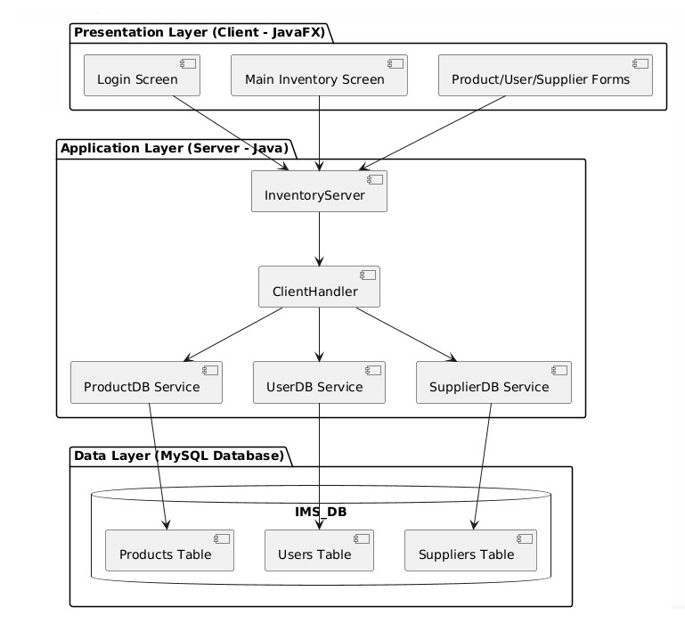
- High-Level Use Case Diagram:
  - Actors: Admin, Staff.
  - Use Cases:
    - Login
    - Manage Products (CRUD)
    - Manage Users (Admin only)
    - Manage Suppliers (Admin only)
    - Low Stock Check
    - Inventory Value Report
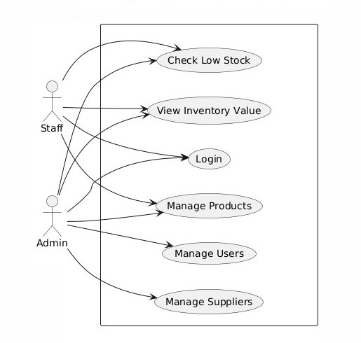

- Sequence Diagram: “Add Product”
  - Lifelines: Staff → _24_CtrlProd → _03_ClientServerLine → _01_InventoryServer → _02_ClientHandler → _12_ModelProdDB → DB.

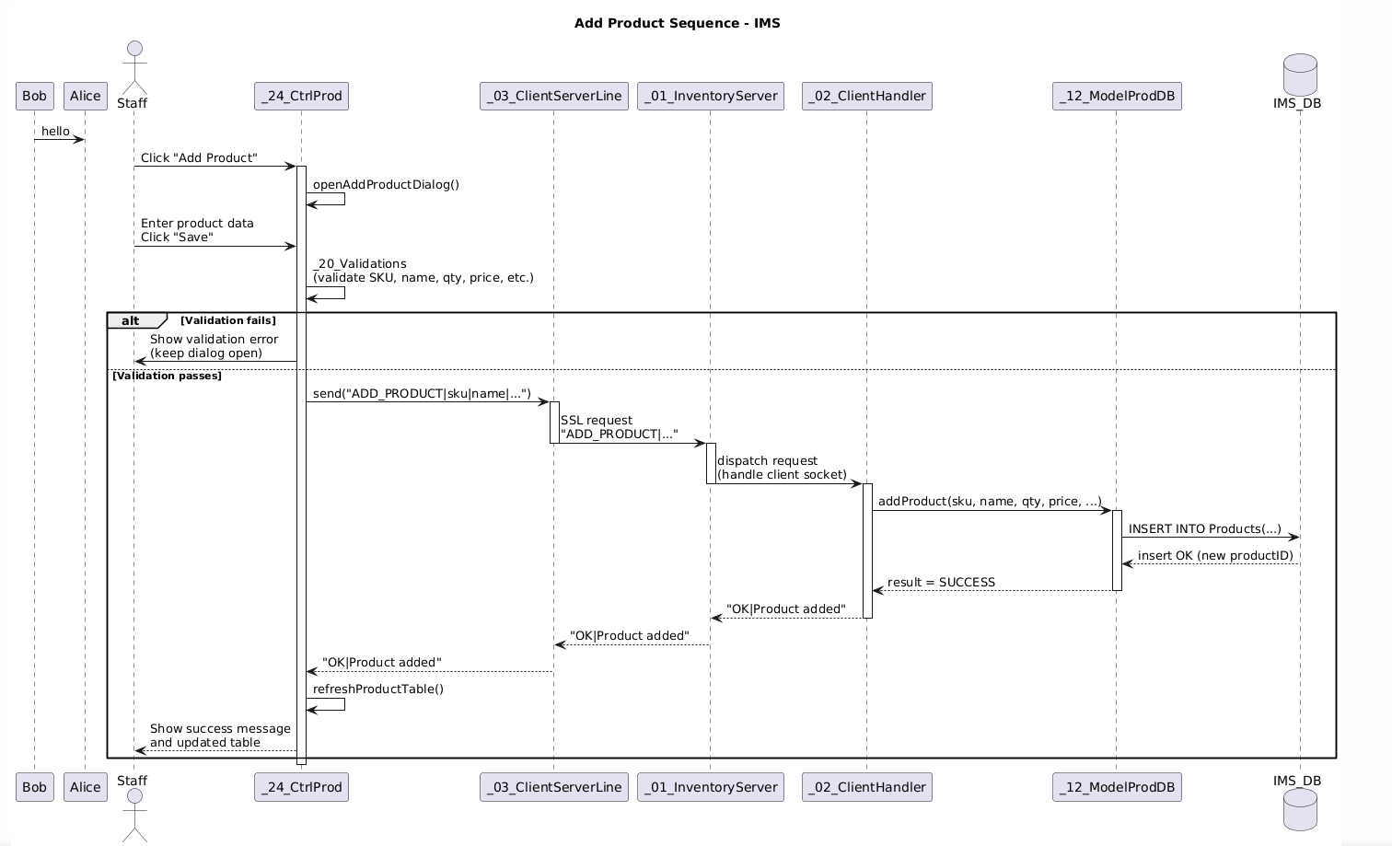

9. Process & Management

9.1 Development Process
- Methodology:
Lightweight iterative / incremental:
  - Plan → Implement → Test → Refine (per feature).
- Milestones:
  - Basic client–server connection + login.
  - Products CRUD.
  - Users & Suppliers CRUD.
  - Low stock & custom actions.
  - Testing and polishing.

9.2 Tools & Technologies
- Language: Java 21
- UI: JavaFX
- Build: IntelliJ + Maven/Gradle
- DB: MySQL/XAMPP (local), future cloud migration
- VCS: Git + GitHub
- Testing: JUnit 5

9.3 Testing Strategy
- Unit tests:
  - _20_Validations, DB model methods, helper utilities.
- Integration tests:
  - Server handlers + DB (e.g., add product, then read back).
- System tests:
  - End-to-end flows: login → product CRUD → low stock check.

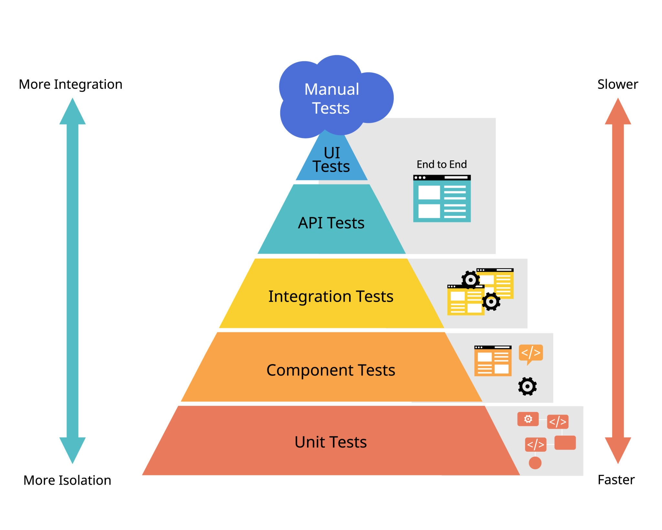

9.4 Risk & Mitigation (Examples)
Risk | Mitigation
DB connection failures | Centralized config, retries, clear error msg.
Data loss | Daily backups, tested restore procedure.
Security vulnerabilities | BCrypt, SSL, input validation, least privilege.
Overcomplexity / scope creep | Fix scope to Products/Users/Suppliers for now.

10. Incident Management

10.1 Incident Report Goals
The aim of this report is to make it easy to:
- capture what happened,
- trace where (client/server/DB), and
- document fix + prevention.

10.2 Example Incident Report (Filled)
1. Date & Time: 2025-11-20 @ 14:32 EST
2. Reported By: Tony Rojas (Admin)
Role: ☐ Admin ☐ Staff ☐ Developer ☐ Other
Environment: ☐ Production ☐ Test ☐ Dev ☐ Local
3. Severity / Priority:
☐ Critical – system unavailable
☐ High – major function broken, workaround not acceptable
☐ Medium – function degraded, workaround available
☐ Low – cosmetic / minor

4. Area Affected (Module):
☐ Login / Authentication
☐ Products (CRUD)
☐ Users (CRUD)
☐ Suppliers (CRUD)
☐ Low Stock / Requisition
☐ Reporting (Inventory Value, etc.)
☐ Server / Network / SSL
☐ Database (MySQL, schema, connection)
5. Brief Title: “Add Supplier fails with ‘DB error: Duplicate Supplier not allowed’”
6. Incident Summary
Short Title: “Add Supplier fails”
Summary (2–3 sentences):
Briefly describe what was observed (e.g., “Add Supplier fails with error and record is not inserted.”)
7. Detailed Description
What Happened?
When trying to add a new product, the client shows an alert “DB error: Duplicate Supplier not allowed,” and the record is not added in the DB.
8. Steps to Reproduce
- Login as Admin.
- Click “View Supplier” then “Add Supplier”.
- Fill all fields with valid data.
- Click “Save”.
9. Expected Result
Supplier should be saved and success message shown, no error dialog.
10. Actual Result
Supplier is not saved. DB error message: Duplicate Supplier not allowed.
11. Users Affected:
☐ Single user
☐ Some users
☐ All users
12. Data Impact:
☐ No data loss
☐ Wrong data stored
☐ Data loss / corruption
Details:
13. Business Impact:
e.g., “Sales could not update stock for 2 hours,” “Admin couldn’t add new staff.”
14. Technical Details (for Developers)
- Client Version / Build:
- Server Version / Build:
- Database Version:
- Relevant Logs / Error Messages:
  - Client log (JavaFX / console):
  - Server log (_01_InventoryServer, _02_ClientHandler):
- Screens / Classes Involved:
  - e.g., _24_CtrlProd, _03_ClientServerLine, _12_ModelProdDB, Products table
15. Root Cause (Admin/Internal)
e.g., “Server was returning generic failure even when DB insert succeeded due to broad exception catch.” Or “Server handler caught a general exception and returned a generic failure message even when the operation partially succeeded.”

1. Category:
☐ Code defect
☐ Configuration error
☐ Database / schema issue
☐ Network / SSL problem
☐ User error / training issue
☐ Other:
2. Technical Explanation (optional detail):
Stack trace snippet, faulty query, wrong validation rule, etc.

16. Resolution & Recovery
- Immediate Fix Applied:
What was done to resolve the incident (code change, DB fix, restart server, etc.). The Company Name was defined as UNIQUE in the DB.
- Data Correction (if any):
Cleared restriction. SQL: SHOW INDEX FROM Supplier;
ALTER TABLE Supplier DROP INDEX supplierName;
- Verification / Testing:
  - Tests performed:
  - Result: ☐ Passed ☐ Failed
  - Tested by: Tony Rojas
- Status:
  - ☐ Resolved
  - ☐ Mitigated (workaround)
  - ☐ Monitoring
  - ☐ Reopened
17. Preventive Actions / Follow-Up
- Narrow server exception handling for product insert:
- On true DB failure → return “FAILURE: …”.
- On success → return “SUCCESS”.
- Update client to only show “Database temporarily unavailable” when response status is a real failure.
- Process / Code Changes to Prevent Recurrence:
e.g., “Add specific error codes to server responses,” “Add JUnit test for ADD_PRODUCT happy path + failure path,” “Tighten exception handling in _12_ModelProdDB.”

Status: Resolved / Verified
Time to Resolution: 2 hours

